**dorc(3 Point)**

Design and code a class named Printer that holds information about a Printer.

| **Printer** | Where:  1. getName():String – return name of a Printer  2. getPrice():double– return price of a Printer |
| --- | --- |
| -price:double  -name:String |
| +Printer()  +Printer(name:String,price:double)  +getName():String  +getPrice():double |

**The interface IPrinter is given (DO NOT CREATE THIS ONE).** Design and code a class named **MyPrinter** which will implement interface IPrinter and complete 2 methods which were declared in IPrinter:

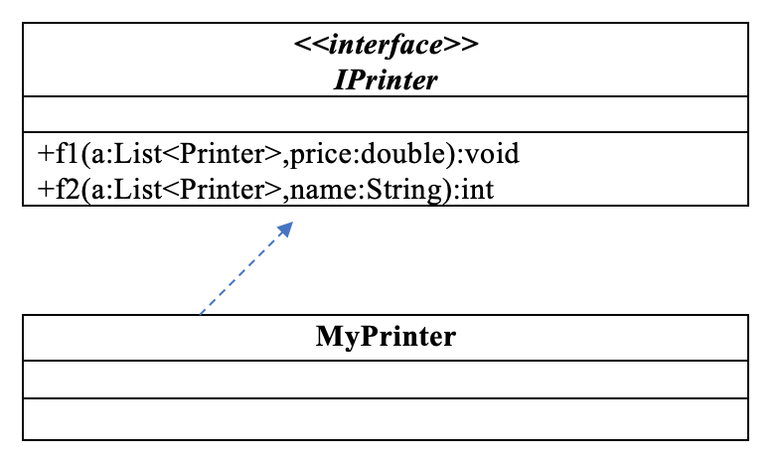

* void f1(List<Printer> a, double price) – remove from the list of printers "a" all printers which has price less than or equals to given price.
* int f2(List<Printer> a, String name) - count and return number of printers which are in the list “a” and has name contains given name. *The comparison must ignores the case during comparison.*

Given some data which is added to list “a” in the Main already:

| **Printer name** | **Printer price** |
| --- | --- |
| HP 200J | 110 |
| HP 2000G | 150 |
| Canon G1240 | 120 |

By using given data, the program output might look something like:

|  |  |
| --- | --- |

item.getName.startWith(name) → count++;